FPGA - Fabric, Design and Architecture
This repository contains all the information studied and created during the FPGA - Fabric, Design and Architecture workshop. It is primarily focused on a complete FPGA flow using the maximum usage of Open FPGA.
Table of Content:
Introduction to FPGA
FPGA vs ASIC Comparison
DAY-1:Exploring FPGA Basic and Vivado
FPGA Architecture
Counter Example in Vivado
DAY-2: Exploring OpenFPGA,VPR and VTR
DAY-3: RISC-V Core Programing Using Vivado
DAY-4: Introduction to SOFA FPGA Fabric
DAY-5: RISC-V Core on Custom Sofa Fabric
Introduction To FPGA
FPGA (Field Programmable Gate Array) are intergated circuits which have a complex arrangement of configurable logic blocks (CLBs) and programmable interconnects.

FPGA vs ASIC Comparison
FPGA | ASIC
Field Programmable Gate Array | Application Specific Integrated Circuit
RTL to Bitstream | RTL to Layout
Reconfigurable Circuit | Permanent Circuit
Less Energy Efficient. Required more power for same task as compared to ASIC | More energy efficient
Useful for prototyping or validating a design | Used for final product design after validation

Day 1 - Exploring FPGA Basics and Vivado

FPGA Architecture
The FPGA Architecture primarily consists of : - Configurable Logic Blocks - Programmable Interconnects - I/O Cells - Memory / Block RAM

Configurable Logic Block
Configurable Logic Block (CLB) is responsible for the combinational or sequential logic implementation. CLB consists of :
- Look-up Table (LUT) - Logic function implementation
- Carry and Control Logic - Arithmetic Operations
- Flip-flops and/or latches
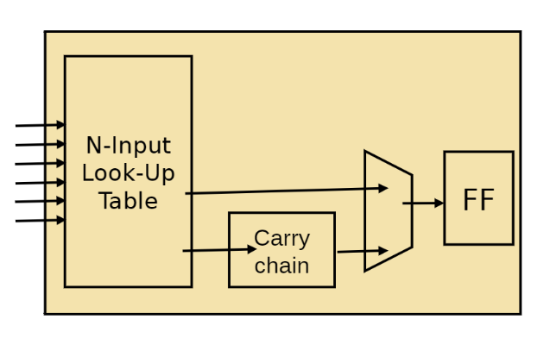Basys FPGA BoardThe FPGA used in this repository is Basys 3 Artix-7 FPGA. Below is the Basys FPGA . aboardandsome major elements on the board 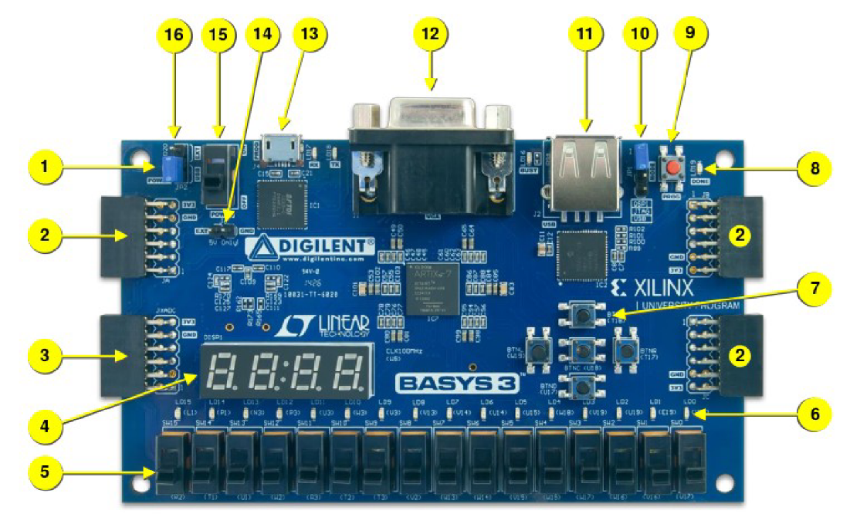
No | Description | No | Description
01 | Power Good LED | 09 | Reset
02 | I/O | 10 | Jumper
03 | I/O | 11 | Interface
04 | Four 7-segment Display | 12 | VGA Connector
05 | Slide switches | 13 | USB Port
06 | LEDs | 14 | External Power
07 | Pushbuttons | 15 | Switch
08 | FPGA programming done LED | 16 | Jumper

Counter Example in Vivado
A 4-bit up counter is being used for exploring the Vivado tool and OpenFPGA. Below mentioned the RTL for the counter modules that is being used
`timescale 1ns / 1ps
//////////////////////////////////////////////////////////////////////////////////
// Description: 4 bit counter with source clock (100MHz) division.

module counter_clk_div(clk,rst,counter_out);

input clk,rst;
reg div_clk;
reg [25:0] delay_count;
output reg [3:0] counter_out;

//////////clock division block////////////////////
always @(posedge clk) begin

if(rst) begin
delay_count<=26'd0;
div_clk <= 1'b0; //initialise div_clk
end
else
if(delay_count==26'd212) begin
delay_count<=26'd0; //reset upon reaching the max value
div_clk <= ~div_clk; //generating a slow clock
end
else begin
delay_count<=delay_count+1;
end
end
end

/////////////4 bit counter block///////////////////
always @(posedge div_clk) begin

if(rst) begin
counter_out<=4'b0000;
end
else begin
counter_out<= counter_out+1;
end
end

endmodule

Counter Simulation and Elaboration
The snippet below shows the behavioural simulation for the up counter.
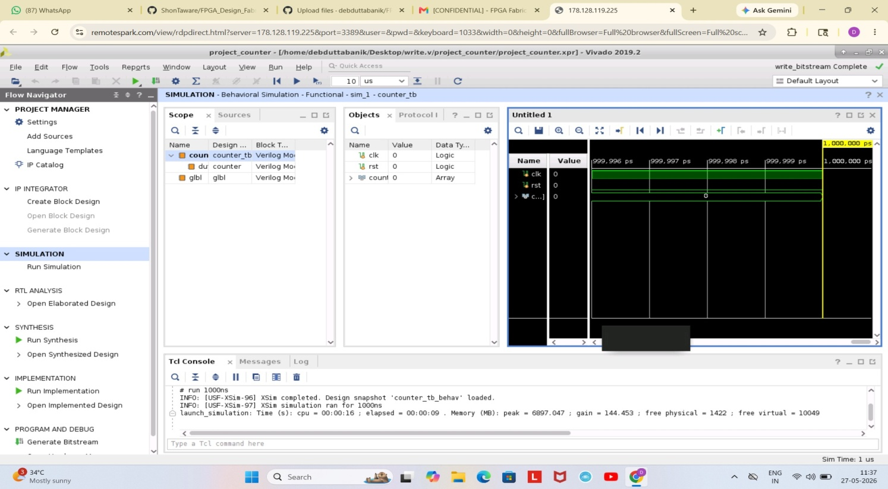
Elaboration binds modules to module instances, builds the model hierarchy, computes parameter values, resolves hierarchical names, establishes net connectivity, and prepares all of this for simulation.
The snippet below is the schematic of the counter design after elaboration.

In I/O planning, the ports for modules are assigned respective FPGA pins. The snippet below shows the details about I/O planning.
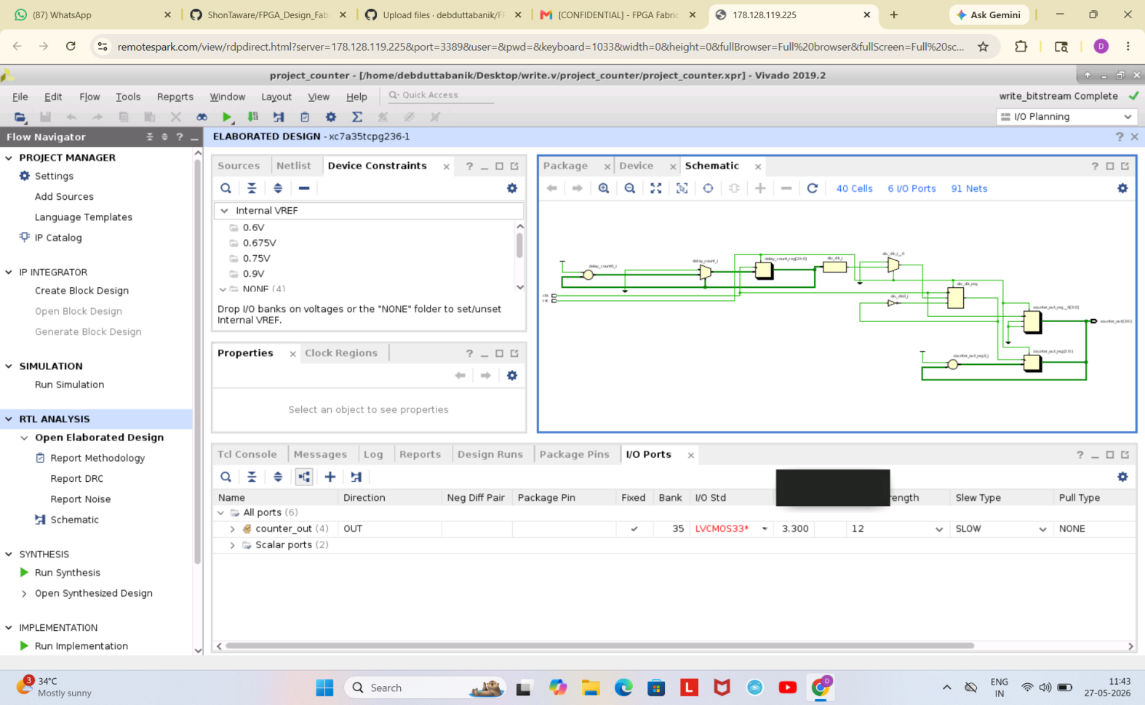
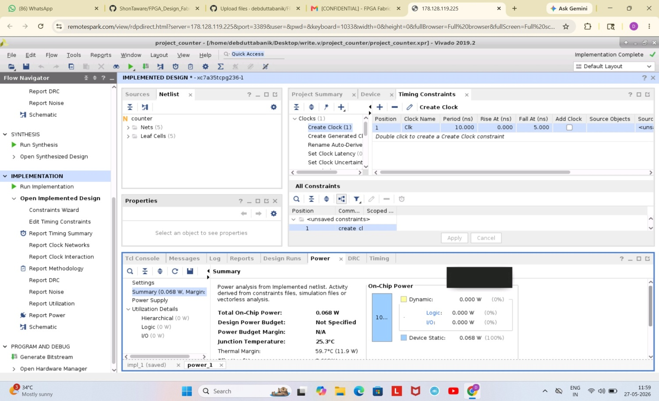

Counter Synthesis
Synthesis is the process that converts RTL into a technologyspecific gate-level netlist, optimized for a set of pre-defined constraints.
The below snippet show sthe schematic generated by the Vivado synthesis tool. 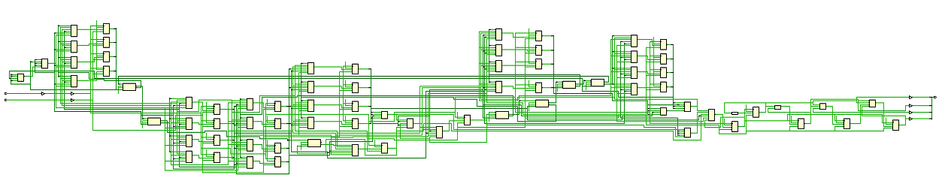

Constraints
Constraints in simple are the specifications of your design like timing specifications, ports declaration, input/output delays, etc.

Day 2 - Exploring OpenFPGA, VPR and VTR

Introduction To OpenFPGA
The OpenFPGA framework is the first open-source FPGA IP generator which supports highly-customizable homogeneous FPGA architectures. OpenFPGA provides a full set of EDA support for customized FPGAs, including Verilog-to-bitstream generation and self-testing verification. OpenFPGA targets to democratizing FPGA technology and EDA techniques, with agile prototyping approaches and constantly evolving EDA tools for chip designers and researchers.
Some key features of OpenFPGA are: - Use of Automation Techniques - Reduction of FPGA developement cycle to few days - Provides open source design tools
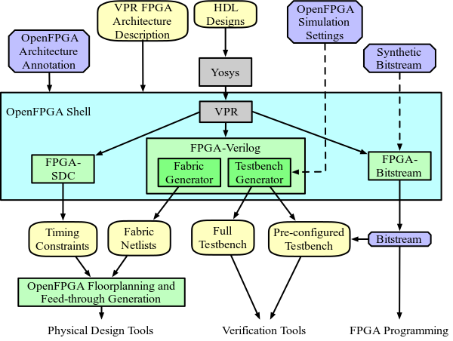

VPR
VPR (Versatile Place and Route) is an open source academic CAD tool designed for the exploration of new FPGA architectures and CAD algorithms, at the packing, placement and routing phases of the CAD flow. As input, VPR takes a description of an FPGA architecture along with a technology-mapped user circuit. It then performs packing, placement, and routing to map the circuit onto the FPGA. The output of VPR includes the FPGA configuration needed to implement the circuit and statistics about the final mapped design (eg. critical path delay, area, etc).
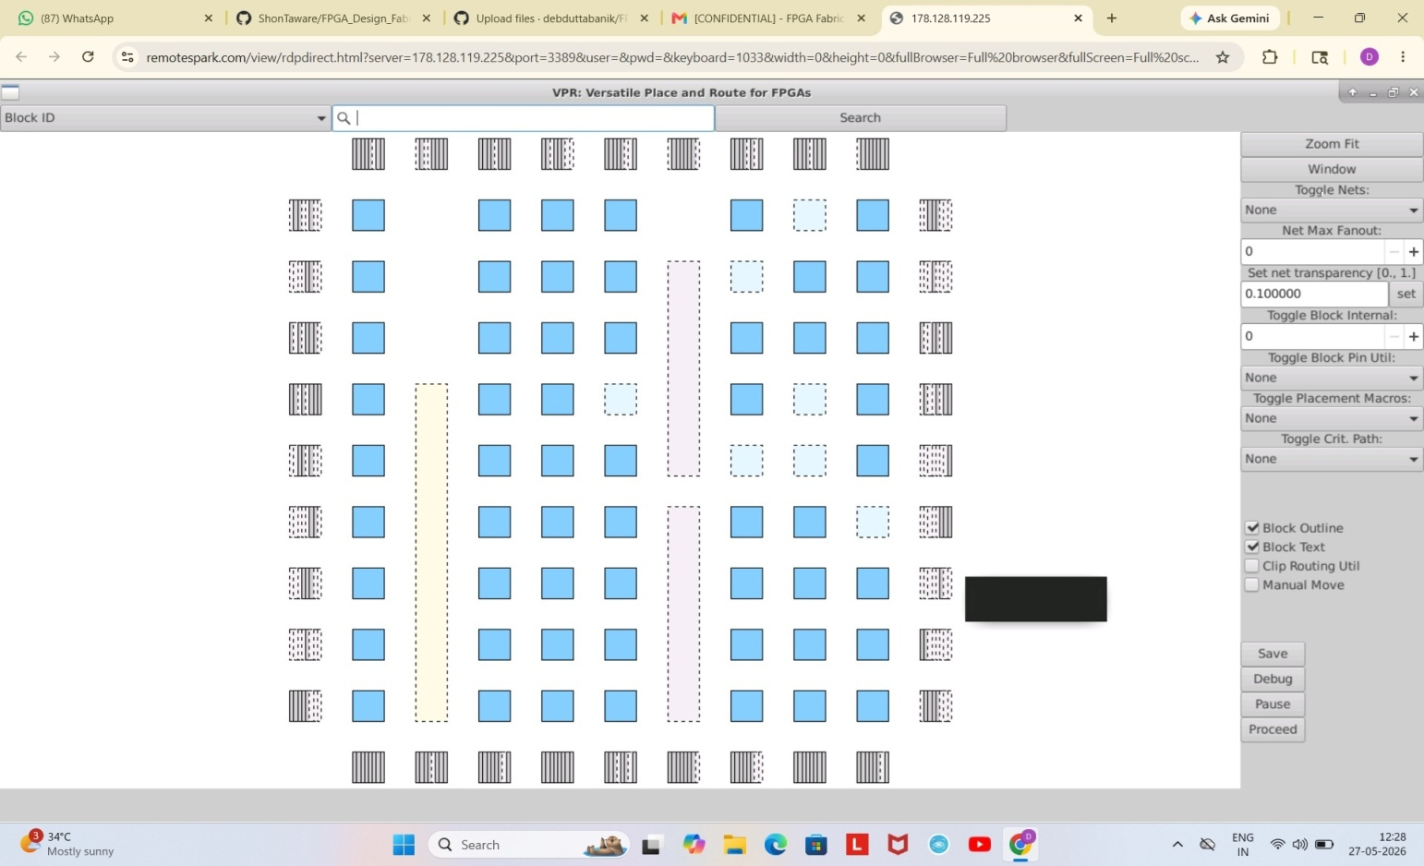

To invoke VPR from terminal:
$VTR_ROOT/vpr/vpr \
$VTR_ROOT/vtr_flow/arch/timing/EArch.xml \
<blif-file-path \
--route_chan_width 100 \
--disp on
The basic VPR flow involves below mentioned steps:
- Packing - combinines primitives into complex blocks
- Placment - places complex blocks within the FPGA grid
- Routing - determines interconnections between blocks
- Analysis - analyzes the implementation

VTR
The Verilog to Routing (VTR) project provides open-source CAD tools for FPGA architecture and CAD research. The VTR design flow takes as input a Verilog description of a digital circuit, and a description of the target FPGA architecture.
To invoke VTR from command-line:
$VTR_ROOT/vtr_flow/scripts/run_vtr_flow.py \
$VTR_ROOT/doc/src/<verilog-file-path>
$VTR_ROOT/vtr_flow/arch/timing/EArch.xml \
-temp_dir . \
--route_chan_width 100

VTR Flow
The basic VTR flow perfoms:
- Elaboration & Synthesis (ODIN II)
- Logic Optimization & Technology Mapping (ABC)
- Packing, Placement, Routing & Timing Analysis (VPR)

Timing Analysis VTR Flow
In order to perform timing analysis, a constraint file needs to be created. This constraint file is provided as an input to tool.

Post Synthesis Simulation
Post Synthesis simulation in VTR flow is same as Post Implementation simulations in general. To generate the post synthesis netlist for simulation, the below mentioned switch should be enabled in during the VPR stage in VTR flow.
## To generate post synthesis netlist
--gen_post_synthesis_netlist on

Power Analysis VTR
VTR provides a option to perform power analysis over the design. To enable power analysis in command-line, the switch mentioned below should be used.
## For power analysis
-power -cmos_tech $VTR_ROOT/vtr_flow/tech/PTM_45nm/45nm.xml

Day 3 - RISCV Core Programming Using Vivado
A 4-stage pipelined RISC-V core, named RVMYTH, is used in the repository. A complete RTL to Bitstream flow is implemented over the RVMYTH core. The Core is initially developed in High-level language named TL-Verilog and finally compiled to Verilog HDL.

RTL To Synthesis
The RISC-V RTL consists of multiple blocks/modules. Some of them are:
- Instruction memory
- Data memory
- ALU
- I/O ports
The snippets below shows the behavioural simulation of the RVMYTH RISC-V core in vivado simulator. The instruction memory contains instructions for addition of integers from 1 to 9. I could not get output as I got error for this simulation.
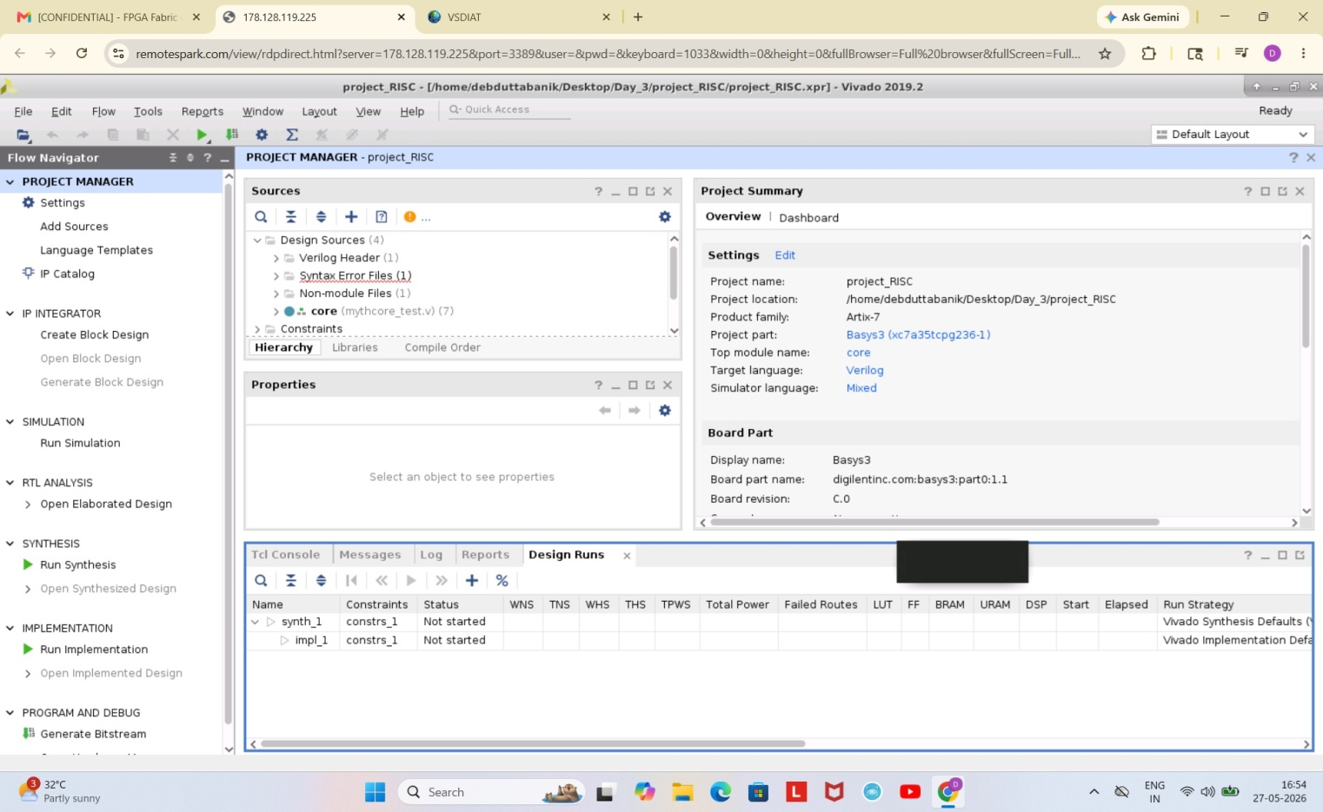

Synthesis To Bitstream
During implementation, the synthesis design is traslated to a logic design file and mapped to small blocks and sub-blocks that can fit in FPGA CLBs. These blocks are then placed and routed in a optimized way.
.

Day 4 - Introduction To SOFA FPGA Fabric
SOFA (Skywater Opensource FPGAs) are a series of open-source FPGA IPs designed using open-source Skywater 130nm PDKs and OpenFPGA framework.
The FPGA IP design used in this repository is FPGA1212_QLSOFA_HD_PNR which has 50MHz of maximum operating speed, 1152 LUTs, 2304 Flip-flops, 1152 soft adders. The complete design is used over OpenFPGA framework and the various reports are generated.

SOFA Counter Area
The snippet below shows the utilization of the counter in SOFA FPGA Fabric.

SOFA Counter Post Implementation
The snippet below shows the post implementation simulation of the counter in SOFA FPGA Fabric.
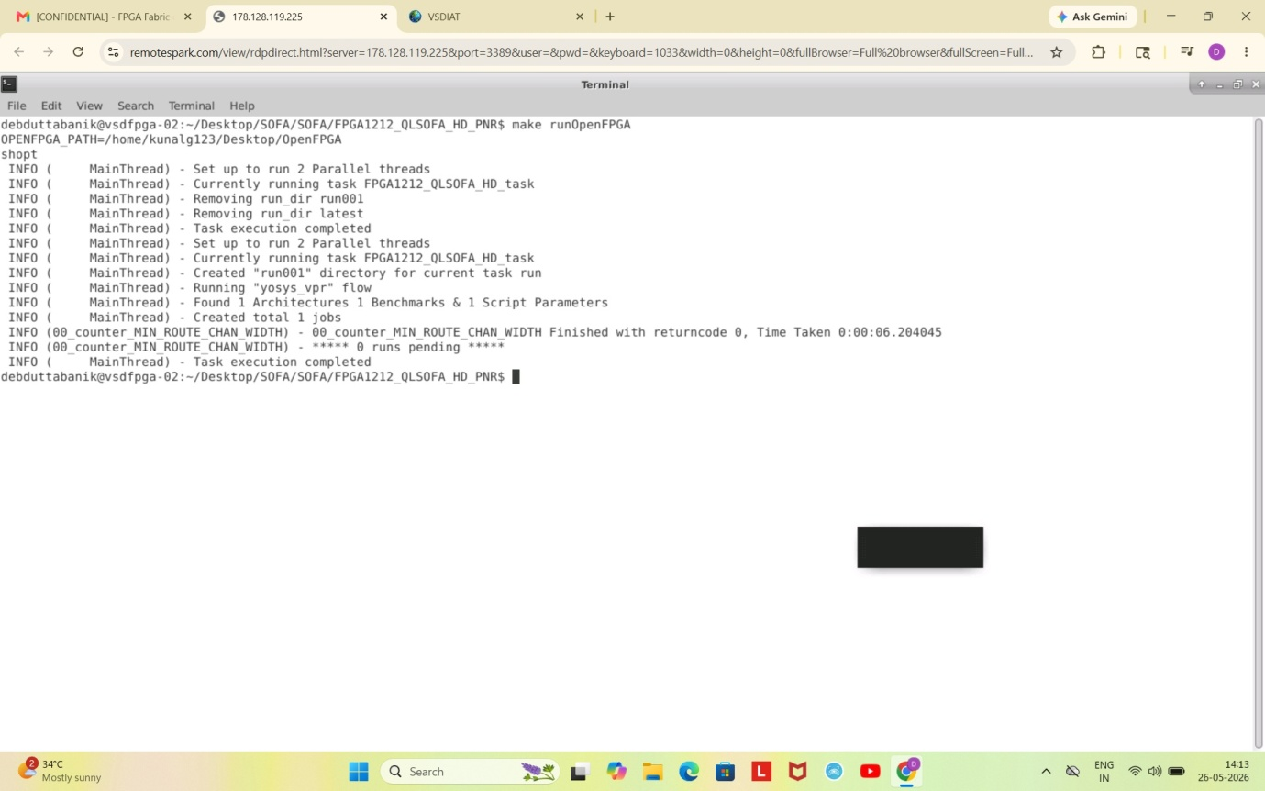

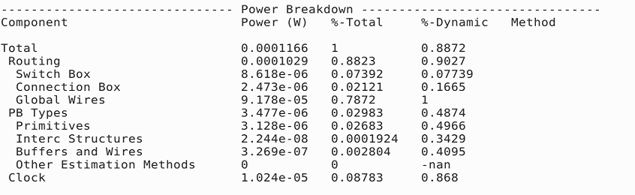

Day 5 - RISCV Core on Custom SOFA Fabric
The RVMYTH discussed is now used along with the custom SOFA FPGA fabric. The design is then taken through the complete OpenFPGA framework and VTR flow. The various logs and reports generated as the outcome of the flow .

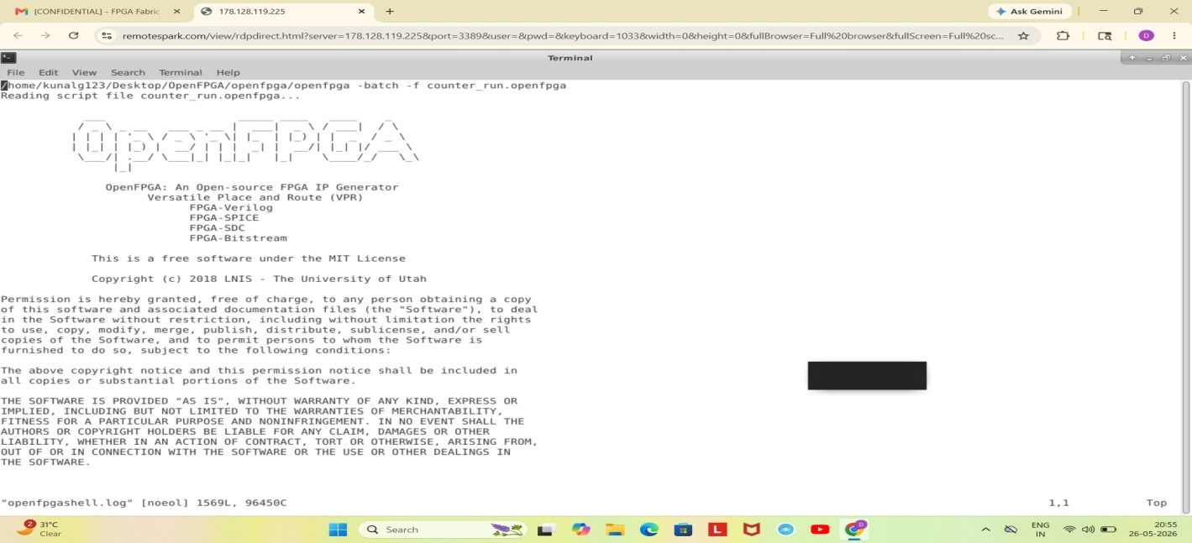 SOFA RVMYTH Utilization
The snippets below shows the device utilization for RVMYTH core on SOFA FPGA Fabric by the tool.
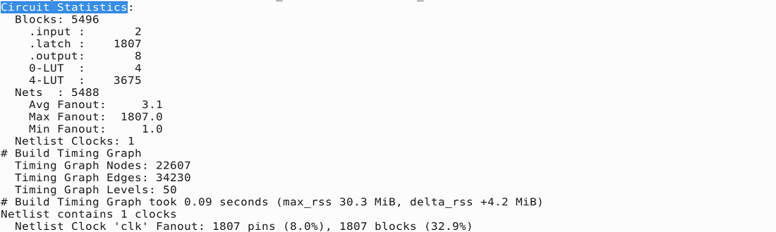 | 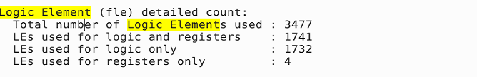

References
- VLSI System Design: https://www.vlsisystemdesign.com/ip/
- RISC-V based Microprocessor: https://github.com/shivanishah269/risc-v-core
- 4-stage RISC-V Core: https://github.com/ShonTaware/RISC-V_Core_4_Stage
- SOFA: https://github.com/lnis-uofu/SOFA
- OpenFPGA: https://openfpga.readthedocs.io/en/master/
- VPR: https://docs.verilogtorouting.org/en/latest/vpr/
- VTR: https://docs.verilogtorouting.org/en/latest/

Acknowledgement
- Kunal Ghosh, Co-founder, VSD Corp. Pvt. Ltd.
- Nanditha Rao

About
This repository contains all the information studied and created during the FPGA - Fabric, Design and Architecture workshop. It is primarily focused on a complete FPGA flow using the maximum open-source tools.

